

ICT-project documentation

RATE-A-MATE



**TEAM DESCRIPTION**

We Team-08 consists of four members, which includes

1. Chaithanya Krishna.
2. Preetham Reddy Todima.
3. Pruthvi Muniraj.
4. Rohan Salla.

We are developing a Mobile application for Universities Students. This is an application where we could analyse student’s ability to work in projects based on citizenship behaviour, team work, leadership and work product.

**TEAM CONTRIBUTION:**

|  |  |  |  |  |  |  |
| --- | --- | --- | --- | --- | --- | --- |
| **Team Member** | Planning | Documentation | Design | Research | Client Agreement | Prototype |
| **Chaitanya Krishan** |  |  |  |  |  |  |
| **Preetham Reddy** |  |  |  |  |  |  |
| **Pruthvi Muniraj** |  |  |  |  |  |  |
| **Rohan K Salla** |  |  |  |  |  |  |

**PROJECT DESCRIPTION**

**PROJECT JUSTIFICATION:**

The main intension to design this application is to estimate student’s ability towards working on a project based on certain criteria. Depending upon Citizen behaviour, user rate’s a mate on how promptly he arrives to group meetings, attends group meetings, completes his given work on time, if he is thoroughly prepared for group meetings and notifies in advance of late meetings .

Considering teamwork as criteria, user rate’s a mate on his behaviour in group discussion or how good he participates in group discussions , how creative he is while he offers an idea or suggest ideas, ready to criticism or answer questions , acknowledges expertise of others , to ensure he does not dominate group discussions, if he is willing to give and take suggestions , listens attentively to others and follows through deliverables.

Leadership, as most important criteria, the user rate’s a mate from Solicits divergent opinions which is estimated by others, shares his leadership goals with other members, suggests important issues for discussions, how good he keeps his discussion focused on key issues raised by clients, helps others when own work is finished and pulls a project together at the end.

Depending on the student’s Work product, the user can rate a mate on how good he can explain own work to others, corrects his own problems, how good he conducts research as needed to the project. The Student should be able to write in agreed upon style, check if submitted work Is complete, written work is professional, oral presentations is well rehearsed and output consistent with expectations

Considering average rating of all the criteria above the solution is gained by rating a student from the scale 0-5.

Depending on average scores the user decides if he wants to work or consider the student for the project followed by giving additional comments.

**MARKET RESEARCH:**

**Sarahah**  is a social networking service for providing anonymous feedback.Sarahah allows people to text messages to others and the person reading that could then reply anonymously.It was released on the play store on June 13, 2017.After Sarahah is successfully downloaded, it will ask you to set up an account. Put in the required details like username, name, email, and a password. This messaging app doesn’t require your mobile number, as the idea is to stay anonymous.

Once logged in, you can share your Sarahah link on Facebook, Twitter, WhatsApp or copy the link and post it to a different social network. So, anyone who has the link will be able to send you messages. This could be friends, even strangers who are on the app or those who have not yet downloaded the app.

For sending a message, a user has to click on the link, which will open a text box with a message, “Leave a constructive message.”  People can type in their message and hit send. When a user receives the message, they just get the text and don’t know who sent this particular message.A user can report a message, block the user. Further, a person can decide to become invisible by going on the option of ‘Appear in search’ and disabling it. Another setting ensures that non-registered users can’t message you on the app. The app shows four icons below each message – a red flag to report message, block icon, reply, and a heart icon to mark a message as favourite.

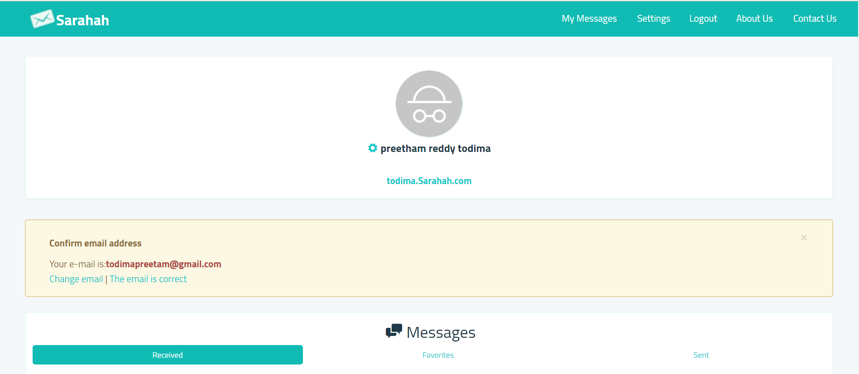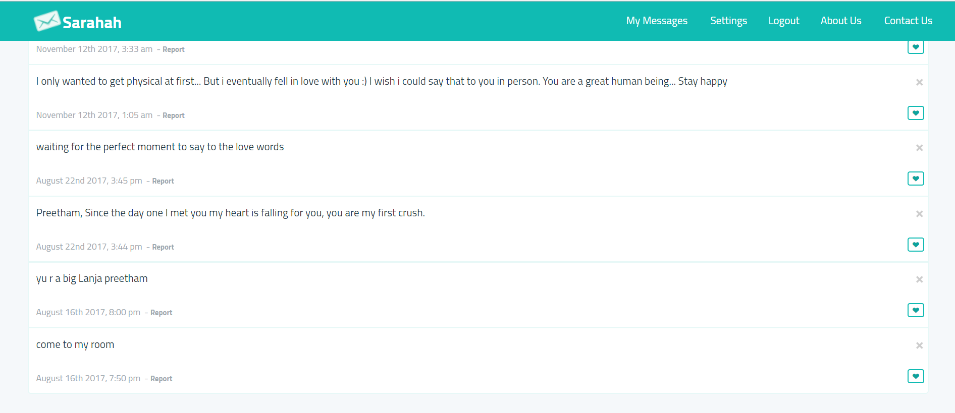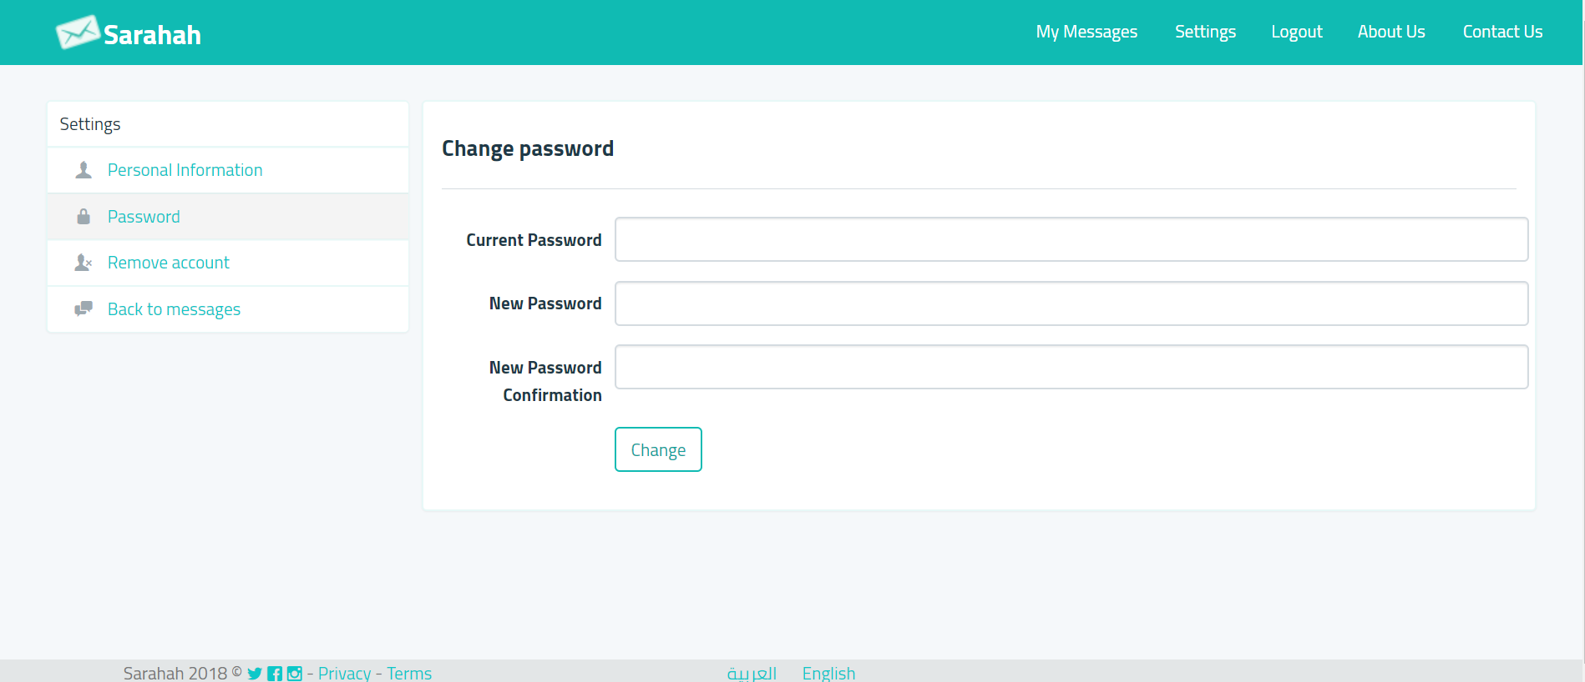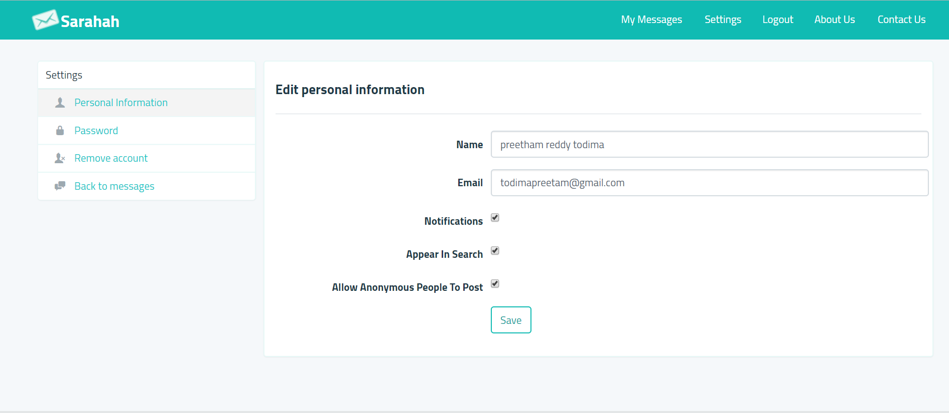

**PROJECT GOALS**

* The most important goal is to design and develop a mobile application for University Students.
* Provide Confidentiality for all the content and user profiles in the application.
* Design and develop functionalities according to the client requirement.
* Design better user interface with maximum effectiveness by avoiding unnecessary and unwanted options.
* To develop a highly efficient mobile app with minimum complexity in operation and quick and easier functionalities.

**PROJECT TIMELINE**

|  |  |  |  |
| --- | --- | --- | --- |
| **RELEASE VERSION** | **NO** | **FEATURES** | **DATE OF RELEASE** |
| **Alpha  5 weeks** | 1 | Login Details | 29/05/2018 |
| 2 | Change of details |
| 3 | Find a mate |
| 4 | Rate a mate |
| **Beta  5 weeks** | 1 | My rating | 15/08/2018 |
| 2 | Notify New password |
| 3 | Reply to rating |
| 4 | Admin monitoring |
| **Final  5 weeks** | 1 | Testing | 22/09/18 |
| 2 | Bug fixes |
|  |  |  |  |

The above table shows the project timeline based on three milestones and the release of three versions of the application as expected. It is expected to complete the project by the end of 22 September 2018 and the proposed has been agreed by the client. We as a team is confident enough that we can achieve the proposed milestone on time. Additionally, we a group of four are not being over idealistic about as far as possible as we know our impediments and the aptitudes which we have, so we are as of now in track with the learning procedure and to convey the best of us.

Additionally, we assessed the days for every client stories as per its challenges and a lot of time has been distributed to different client stories as an appropriate testing will likewise be directed. In this way, unmistakably we will have the capacity to finish the task as indicated by the arrangement.

**PROJECT AUDIT**

AVAILABLE DAYS: 5*2*4 = 40(TEAM)

TOTAL ESTIMATED DAYS: 40 (PROJECT)

INDIVIDUAL AVAILABILITY:(2 DAYS/WEEK)

TOTAL NO OF WEEKS: 5

**MILESTONE 1: ALPHA RELEASE**

Alpha release is the first stage in the release of the mobile application and only the features which are mentioned below will be delivered in the estimated time.

USER STORIES: ALPHA

|  |  |  |  |
| --- | --- | --- | --- |
| **TITLE** | **DESCRIPTION** | **CLIENT PRIORITY** | **TIME ESTIMATE (DAYS)** |
| Login | User logins with his jc number and pre-defined password | 10 | 10 |
| Details change | Student Validates his/her student ID, email and password and prompted to change his/her login credentials. | 10 | 10 |
| Find  a mate | User searches for his/her mate by student id number to rate them | 20 | 10 |
| Rate  a mate | User rates from 0-5/NA based on the criteria provided. | 20 | 10 |

The development for the Alpha release will start from the mid-week of 22-04-18 and it is expected to release on 29/05/2018.

Total of 40 days has been allocated for the Alpha development process and each one of the group member will spending two day per week for that 5 weeks. Which in turn will contribute to a total of 40 days.

**MILESTONE 2: BETA RELEASE**

Beta is the second stage in the development stage and it is estimated to complete and release the beta version on 09/07/2018. The time limit spared for the development of Beta version is also 5 weeks.

USER STORIES: BETA

|  |  |  |  |
| --- | --- | --- | --- |
| **TITLE** | **DESCRIPTION** | **CLIENT PRIORITY** | **TIME ESTIMATE (DAYS)** |
| My rating | User can see his own ratings and gets a notification when his mate rates him/her. | 30 | 10 |
| Notify  new password | User receives an email to setup a new password if he wishes to change the pre-defined password. | 30 | 10 |
| Reply  to rating | User can reply to the ratings received. User won’t be able to see the name of the mate who has rated him/her but can comment on the ratings. | 40 | 10 |
| Admin Monitoring | Admin can see all the ratings and monitor them according to project priorities. Notify admin if he/she suspects the rating received is not legit | 50 | 10 |

Each team member will spend the same amount of time as in Alpha release and Beta version is also estimated to take 40 days.

**MILESTONE 3: FINAL RELEASE**

Milestone 3 is the final stage of the project and a fully functional mobile application is estimated to deliver at the end of this stage to the client. Final stage of development is also estimated to have 40 days and each team member will spend two day per week for 5 weeks.

USER STORIES: FINAL

|  |  |  |  |
| --- | --- | --- | --- |
| **TITLE** | **DESCRIPTION** | **CLIENT PRIORITY** | **TIME ESTIMATE (DAYS)** |
| Testing | Testing the app with JCUB students and collect the results for further development | 40 | 20 |
| Bug fixes | Security measures and fixing problems – Admin can perform testing and fix if any bugs in the app. | 50 | 20 |

**CLIENT EMAIL:**

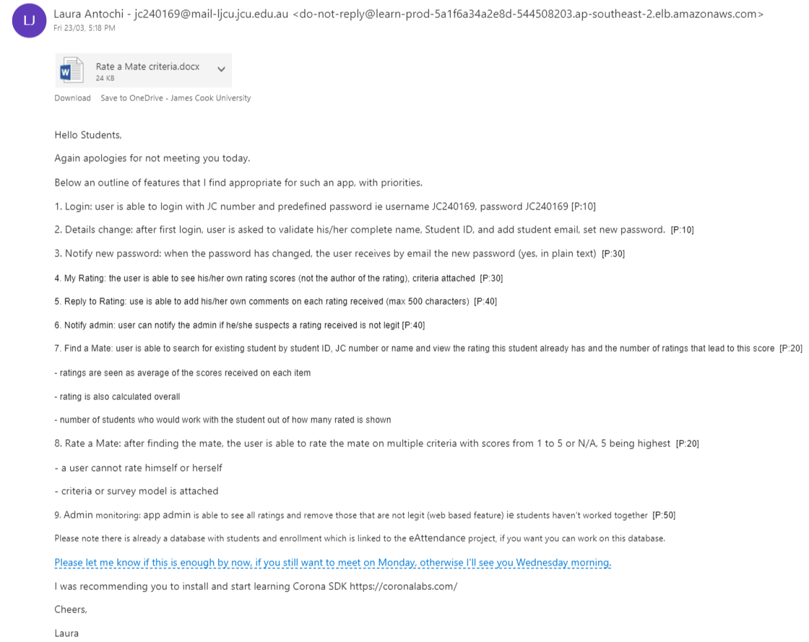

**CLIENT AGRIMENT:**

**ICT ADVANCED PROJECT AGREEMENT**

This Agreement for CP5046 - CP5047 ICT Advanced Project (the “Agreement”) is signed between:

**Chaithanya Krishna,Preetham Todima,Pruthvi Muniraj ,Rohan Salla**

(the "Developers")

James Cook University Brisbane, 349 Queen Street Brisbane, Queensland AND

**Rate A Mate** represented by **Laura Antochi** (the "Client")

James Cook University Brisbane, 349 Queen Street Brisbane, Queensland

The Agreement governs the rules between the Client and the Developers regarding the project to be developed as academic subject at James Cook University Brisbane.

1. **PROJECT DESCRIPTION AND GOALS**

* The main intention to design this application is to estimate student’s ability towards working on a project based on certain criteria.
* The targeted users of this Android application are college,University Students especially JCU Brisbane students.
* Provide Confidentiality for all the content and user profiles in the application.
* To develop a highly efficient mobile app with minimum complexity in operation and easier functionalities.
* The application is developed in three phases and will be available for Android users by 22nd September 2018.

1. **DELIVERABLES**

* Mobile application which supports Android platform and is available through google play store.
* Provide App prototypes.
* Deliver Support for admin from client to monitor the application.
* Provide Documentation,Source Code and User manual to the client.

1. **APPROACH TO DEVELOPMENT**
2. This project has the timeframe between the **23rd April 2018 and 22nd September 2018** to be completed and is subject to the trimester structure corresponding to Study Periods 21 and 22 2018 from James Cook University Brisbane.
3. The approach taken for project implementation is dictated by the corresponding Subject Outline and is based on Agile methodologies:The First Iteration will be dedicated to gathering requirements and project planning; the Second Iteration will be dedicated to implementing the highest priority requirements leading to Alpha Release.Similarly, the Third Iteration will lead to Beta release and The Fourth Iteration to the Final release.
4. Between releases, the Developers will seek the Client’s feedback on the implemented requirements and will revisit the requirements to be developed. It is envisaged that the Client will give timely feedback on the Developers’ work and will allow the necessary time for meetings and discussions. The Developers and the Client will negotiate on the requirements to be developed considering the time constraint.
5. For educational purposes, the Developers might be asked to implement a series of requirements that the Client does not need. In this case, the Developers will remove these features from the project version delivered to the Client.
6. Project release data and content (for example website content such as About us, FAQ, Policy, Disclaimer etc) is to be provided by the Client and it is not part of the development process. The Developers can contribute with data and content for testing purposes.
7. The developing environment is to be configured by the Developers using resources provided by James Cook University Brisbane. If the implementation requires the use of software which is not freely available, the Client should provide access to it.
8. The Developers are responsible of code backup for the whole duration of the project. After the project’s termination, operations such as backup, updates or content changes are the responsibility of the Client.
9. For marking purposes only, the Developers will submit copies of the Project Source Code after each release.
10. **TIMELINE AND PROJECT REQUIREMENTS**

The following scheme describes the timeline of implementation.

a) Alpha release:

* Start date:23rd April 2018
* End date: 29th may 2018
* Requirements to be developed:

|  |  |  |  |
| --- | --- | --- | --- |
| **TITLE** | **DESCRIPTION** | **CLIENT PRIORITY** | **TIME ESTIMATE (DAYS)** |
| Login | User logins with his jc number and pre-defined password | 10 | 10 |
| Details change | Student Validates his/her student ID,email and password and prompted to change his/her login credentials. | 10 | 10 |
| Find  a mate | User searches for his/her mate by student id number to rate them | 20 | 10 |
| Rate  a mate | User rates from 0-5/NA based on the criteria provided. | 20 | 10 |

b) Beta release:

* Start date:9th july 2018
* End date: 15thth august 2018
* Requirements to be developed:

|  |  |  |  |
| --- | --- | --- | --- |
| **TITLE** | **DESCRIPTION** | **CLIENT PRIORITY** | **TIME ESTIMATE (DAYS)** |
| My rating | User can see his own ratings and gets a notification when his mate rates him/her. | 30 | 10 |
| Notify  new password | User receives an email to setup a new password if he wishes to change the pre-defined password. | 30 | 10 |
| Reply  to rating | User can reply to the ratings received. User won’t be able to see the name of the mate who has rated him/her but can comment on the ratings. | 40 | 10 |
| Admin Monitoring | Admin can see all the ratings and monitor them according to project priorities.Notify admin if he/she suspects the rating received is not legit | 50 | 10 |

C) final release :

* Start date:15th august 2018
* End date: 22th september 2018
* Requirements to be developed:

|  |  |  |  |
| --- | --- | --- | --- |
| **TITLE** | **DESCRIPTION** | **CLIENT PRIORITY** | **TIME ESTIMATE (DAYS)** |
| Testing | Testing the app with JCUB students and collect the results for further development | 40 | 20 |
| Bug fixes | Security measures and fixing problems – Admin can perform testing and fix if any bugs in the app. | 50 | 20 |

1. BUDGET

a) The deliverables are offered free of charge by the James Cook University Brisbane to the Client through the work of the Developers. The Client may request the implementation of requirements that are excluded from the list above, but this is subject to payment as further negotiated.

b) Any third-party resources which are not freely available, such as templates, images, SSL certificates, licenses, etc are to be purchased and delivered by the Client.

c) Premium Version of Android studio is installed on all the developer systems.

1. **INTELLECTUAL PROPERTY**

a) Any idea or deliverable emerged during the implementation of this project becomes Intellectual Property of the Client. This applies to all development iterations.

b) Third party resources used (templates, themes etc.) are subject to the Terms and Conditions of their Owner.

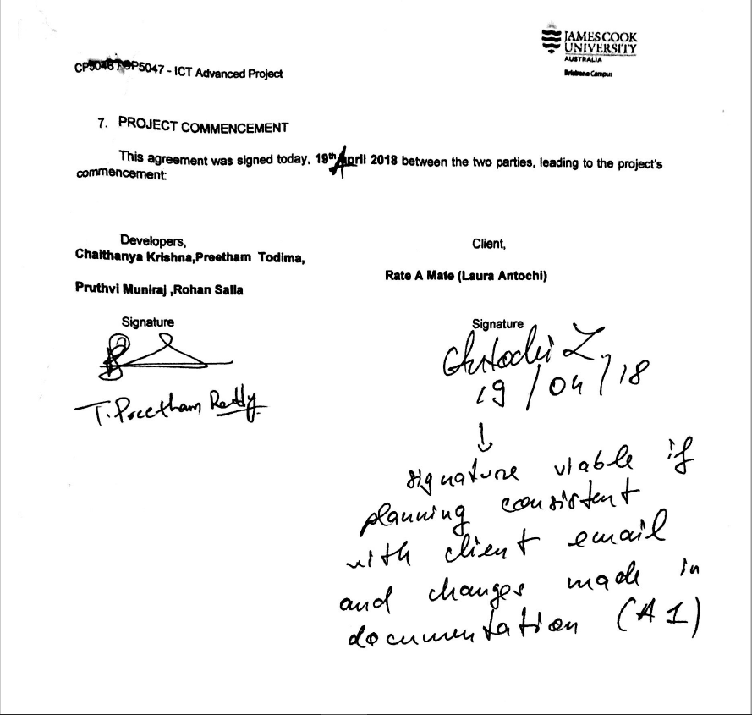

**PROJECT DEVELOPMENT**

**VERSION CONTROL**: Version control or the configuration management is an important tool in software development as multiple people are working on same project.

GitHub is a web-based hosting service for version control using git. It offers all of the distributed version control and source code management functionality of Git as well as adding its own features. GitHub is the configuration management tool used for developing Rate A mate application.

Link: <https://github.com/todima/Rate-A-Mate>

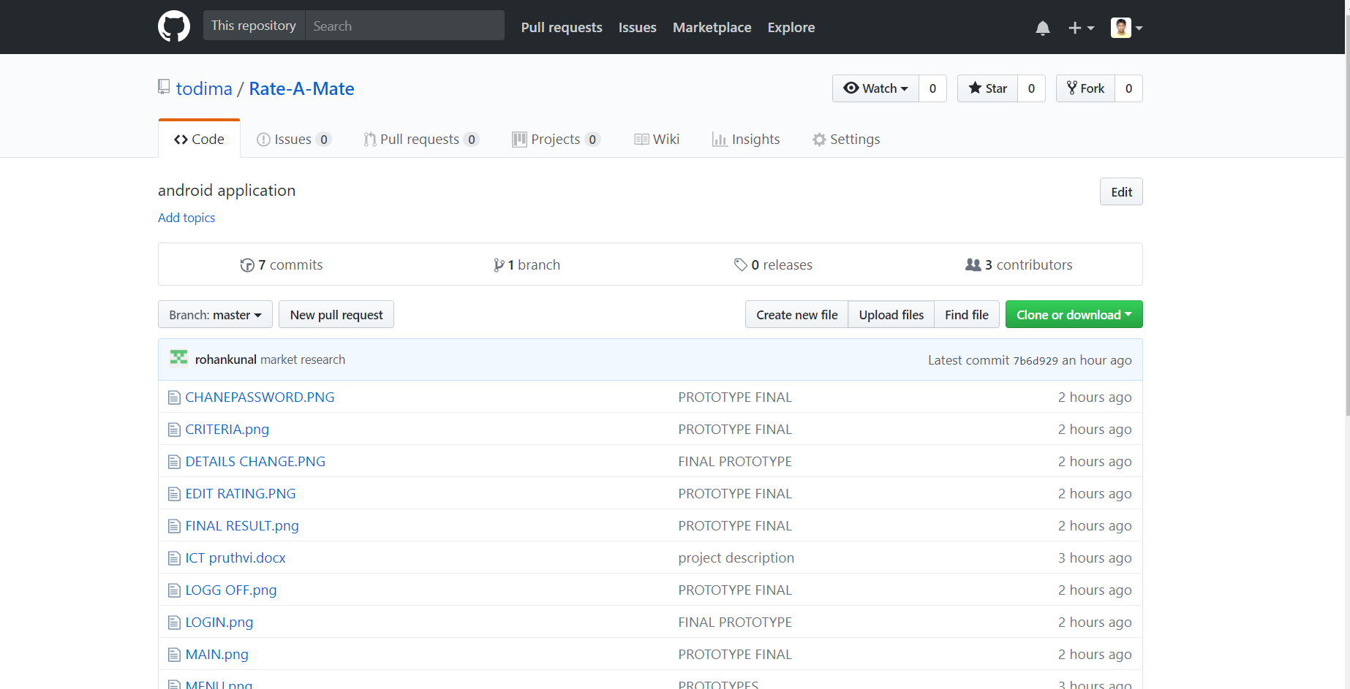

**PROJECT TOOLS**: **Android Studio** is used for the development and JavaScript will be the programming language which is used because of the cross-platform development.

SQL-lite and PHP will be used for the back end and for server-side scripting.

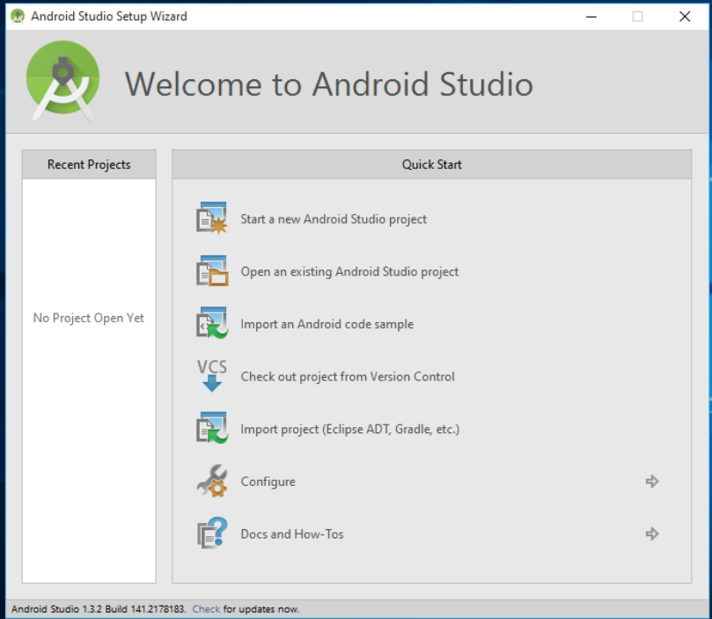

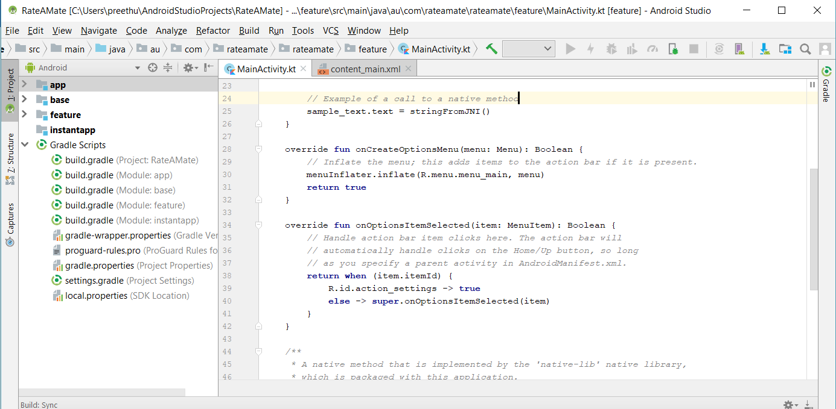

To setup a development environment for a developer in our team first Install Android Studio and then install Cordova Sdk for developing features in the app.

**TESTING TOOLS**:

Testing will be carried out after the development in each stage in real time and various online tools are also available.

Test Complete Mobile is the testing tool which we are planned to test the application.

Also, the test will be conducted with the help of client and with different university students to collect the feedback at different stages of the development.

SAMPLE TEST CASE:

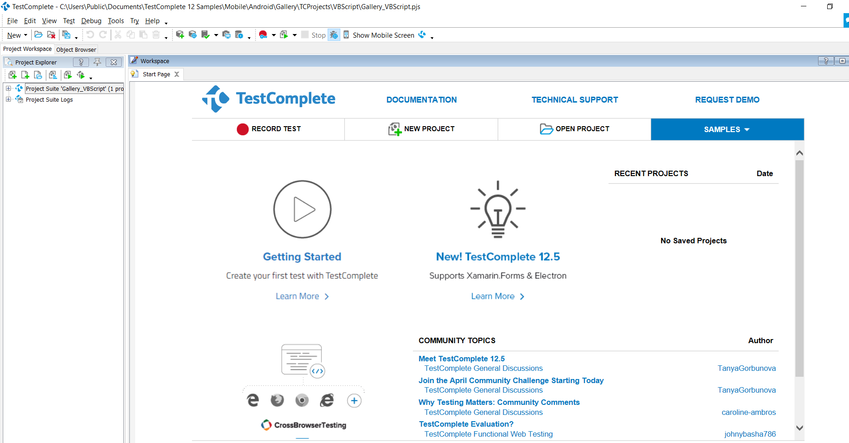

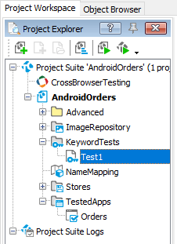

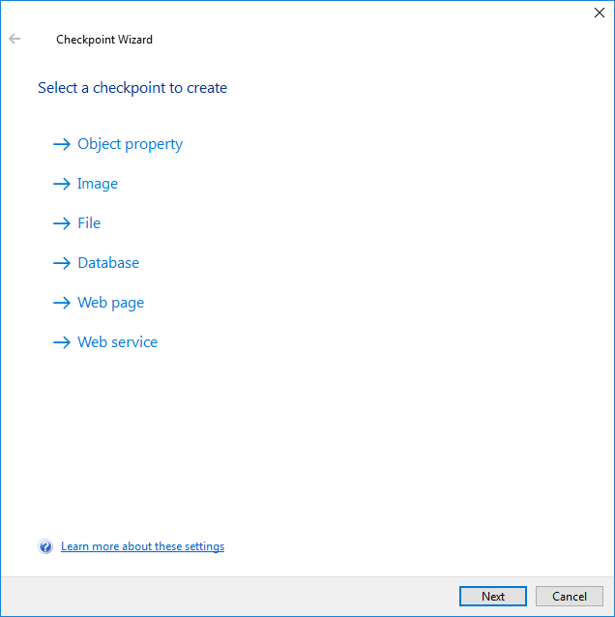

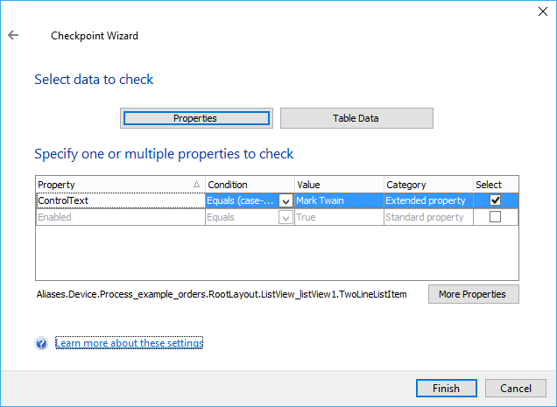

Test case:

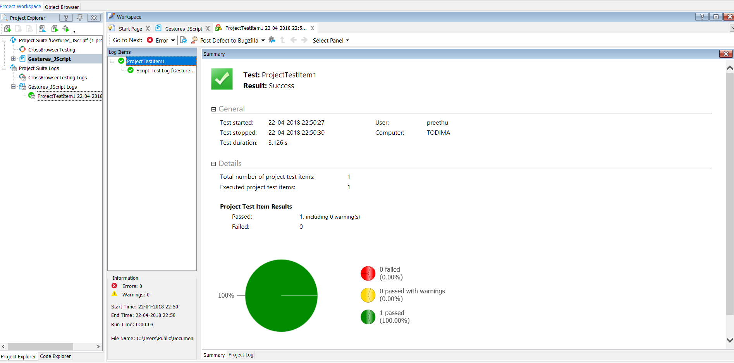

Below details for ICT project hosting, we used these details for the technical infrastructure section of the project. The alpha, beta and final releases will be hosted here.

Web address (subdomain): http:/[rateamate.jcubitgroup.com](http://rateamate.jcubitgroup.com/)

FTP host or server: [ftp.jcubitgroup.com](http://ftp.jcubitgroup.com/)

FTP username: [rateamate@jcubitgroup.com](mailto:rateamate@jcubitgroup.com)

FTP password: 123zxcA!

Database name: jcubitgr_rateamate

Database host or server: localhost (if code hosted on this server) OR [box648.bluehost.com](http://box648.bluehost.com/) (if code hosted somewhere else)

Database username: jcubitgr_ictrate

Database password: 123zxc

**SLACK CHANNEL:** Slack tool is used to communicate and manage the work within the team for the project.

Link: <https://group8rateamate.slack.com/messages>

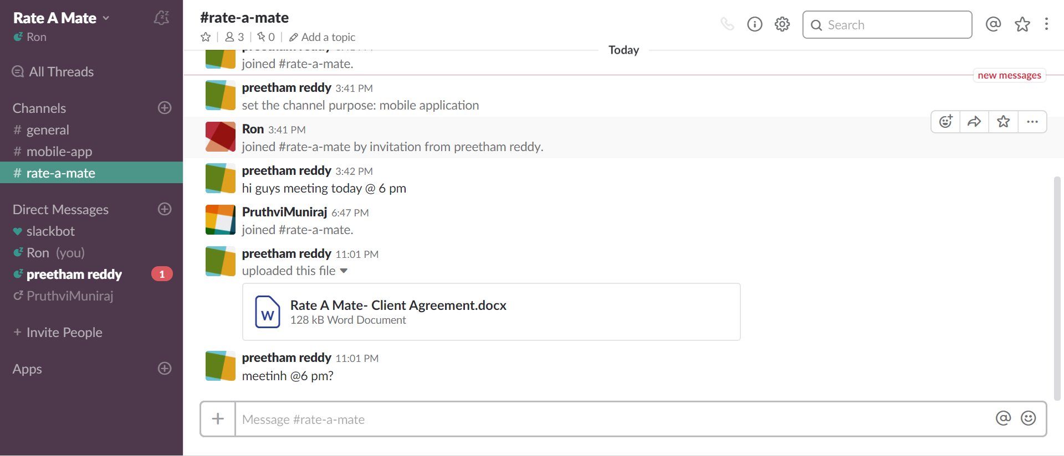

**PROTOTYPES:**

Below are the different prototypes designed for the Mobile application called RATE A MATE.

Tool Used: **Balsamiq Mock-up’s** is used to design the prototypes for mobile application.

**MAIN PAGE:** **LOGIN:**

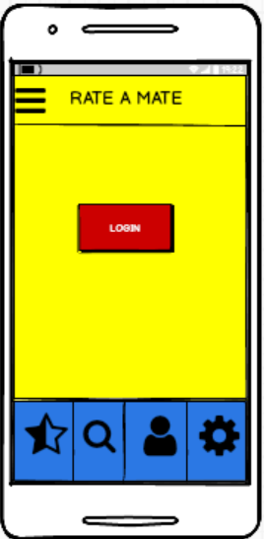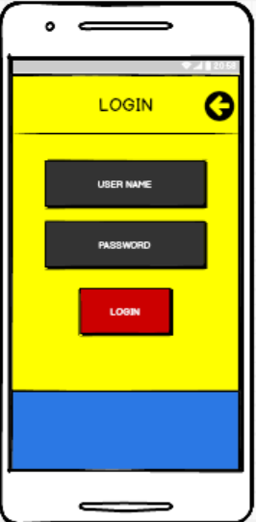

**CHANGE DETAILS: CHANGE PASSWORD:**

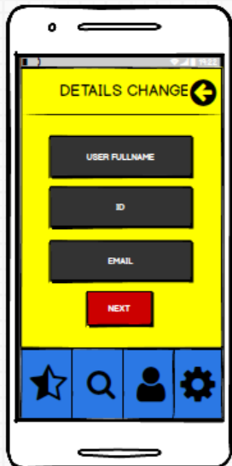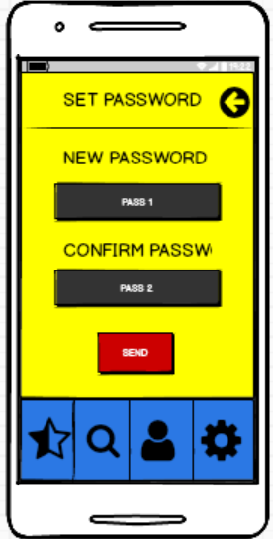

**WELCOME PAGE: SEARCH:**

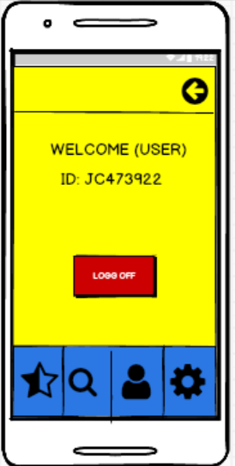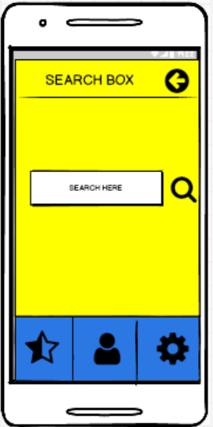

**MENU: MY DETAILS:**

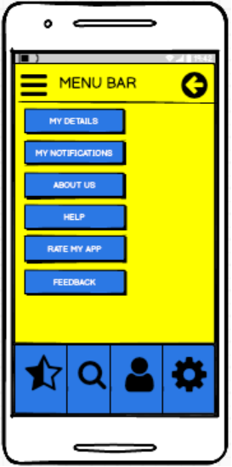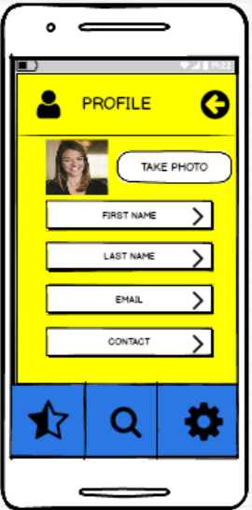

**NOTIFICATIONS: SETTINGS:**

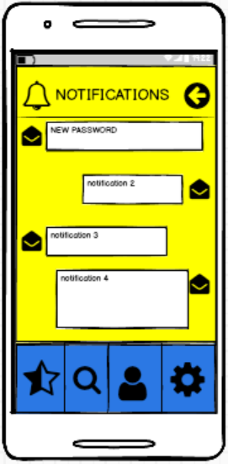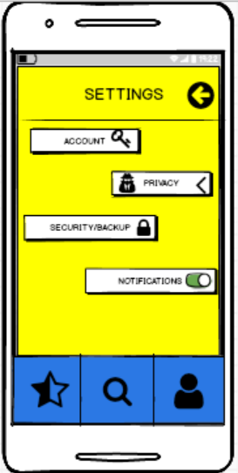

**RATING:** **CRITERIA:**

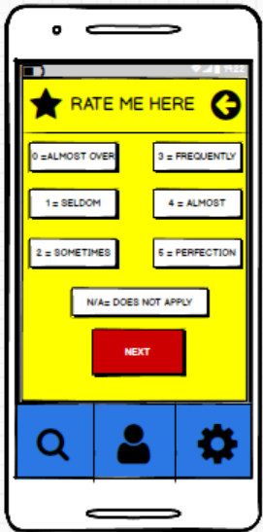 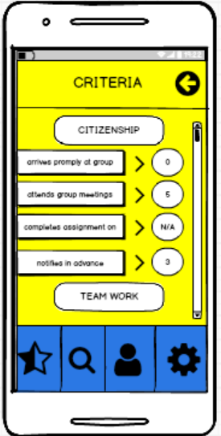

**FINALRATING: REPLY MY RATING:**

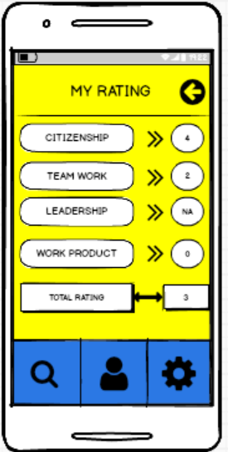 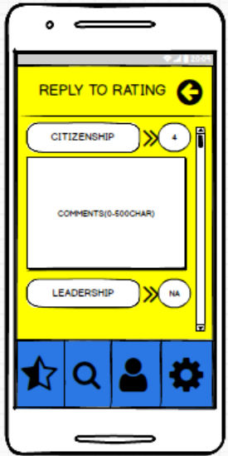

**EDIT RATING:**

